**Fall 2018**

**Intern App**

**Team Members**

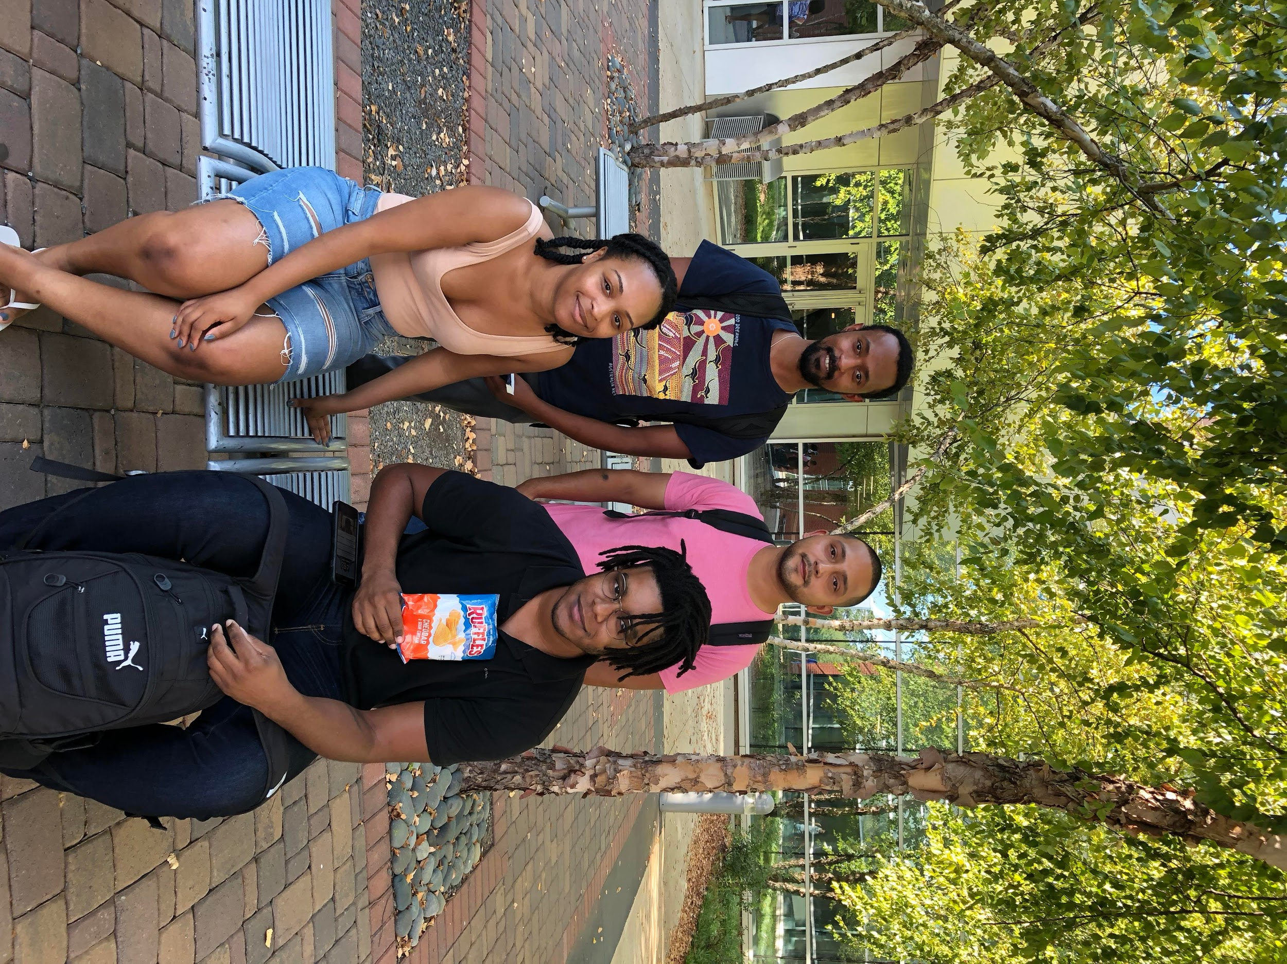

**Left Back: Kidus - QA** & **Team Lead**

**Right Back: Edgar - Documentation Lead** & **Programmer**

**Left Front: Anastasia -Code Architecture/Lead Programmer** & **UI/UX Design**

**Right Front: Billy -Data Modeler** & **Client Liaison**